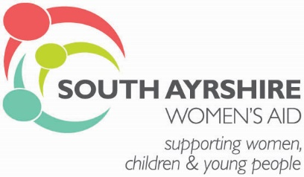

Child Protection Statement:
South Ayrshire Women’s Aid is committed to promoting the rights of children. We are committed to upholding children’s right to be protected from abuse and harm and upholding children’s right to be involved in decisions that affect their lives. We believe that the welfare of children should always be the most important consideration in decisions that affect them.

Protection of Vulnerable Adults Statement:
South Ayrshire Women’s Aid aims to provide the best possible service to the women, children and young people we work with. We believe that women have the right to live a life free from abuse or harm and are committed to providing services that empower women and safeguard vulnerable adults who use our service.

Equal Opportunities Statement:

South Ayrshire Women's Aid recognises that many individuals and communities experience unlawful and unfair discrimination and oppression on the grounds of their gender, race, disability, age, sexual orientation, religion or belief. South Ayrshire Women's Aid believe that equality for all is a basic human right and actively oppose all forms of unlawful and unfair discrimination. We celebrate the diversity of society and strive to promote and reflect that diversity within our organisation.

South Ayrshire Women's Aid will treat all people with dignity and respect, recognising the value of each individual. We are committed to eliminating all forms of discrimination in service delivery, employment and governance on the grounds of race, gender, disability, age, sexual orientation, religion or belief, or responsibility for dependants, HIV\Aids status, or Trade Union membership.

