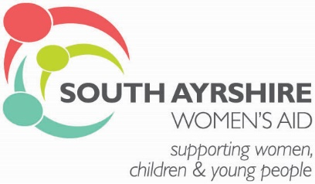

Person Specification:

ESSENTIAL | EVIDENCED
Have a relevant childcare qualification at level 6 or above. | Application
Experience of working with vulnerable groups and women who have experienced trauma. Knowledge of Child Protection procedures. | Application
Understand the issues and support requirements of vulnerable groups. | Application
Ability to communicate effectively both orally and in writing. | Application/Interview
Ability to maintain professional boundaries with children and young people. | Application/Interview
Ability to maintain accurate up to date records of work using a database system. | Application/Interview
Ability to prepare reports as and when required. | Application/Interview
Ability to work on own initiative, managing time effectively and as part of a team. | Application/Interview
Experience of working with vulnerable individual’s assessing risk, strengths and developing support plans | Interview
Ability to establish and maintain effective working relationships with agencies and individuals. | Application/Interview
Driving licence with use of own car | Application
Ability to travel within the South Ayrshire area and others if required. | Interview
Ability to participate in on call rota for our refuge accommodation | Interview
Commitment to equalities and anti-discriminatory practice+ | Interview
FITNESS TO PRACTICE | EVIDENCED
Competent to register with SSSC | Application
DESIRABLE | EVIDENCED
Knowledge of Child Protection Procedures. | Interview
Knowledge of Children’s Hearing systems. | Interview
Knowledge of Adult and Child Protection procedures. | Interview

