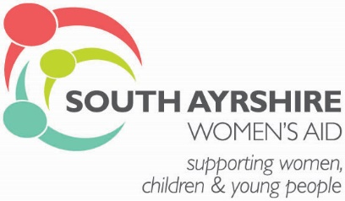

Person Specification:

ESSENTIAL | EVIDENCED
Have or willing to work towards achieving SVQ Level 3 in Health and Social Care | Application
Experience of working with vulnerable groups and women who have experienced trauma | Application
Understand the issues and support requirements of vulnerable women and children | Application
Ability to communicate effectively both orally and in writing | Application/Interview
Ability to maintain professional boundaries with women | Application/Interview
Ability to maintain accurate up to date records of work using a database system | Application/Interview
Ability to prepare reports as and when required | Application/Interview
Ability to work on own initiative, managing time effectively and as part of a team | Application/Interview
Experience of working with vulnerable individual’s assessing risk, strengths and developing support plans | Interview
Ability to establish and maintain effective working relationships with agencies and individuals | Application/Interview
Driving licence with use of own car | Application
Ability to travel within the South Ayrshire area and others if required. | Interview
Ability to participate in on call rota for our refuge accommodation | Interview
Commitment to equalities and anti-discriminatory practice+ | Interview
FITNESS TO PRACTICE | EVIDENCED
Competent to register with SSSC | Application
DESIRABLE | EVIDENCED
Knowledge of Housing Support and Welfare system | Interview
Knowledge of Adult and Child Protection procedures | Interview

